**Smart-glass based**

**Remote Guidance System**

**SOFTWARE QUALITY ASSURANCE PLAN**

Group 21

Lyndon Prado - 9740783

Tingcong Jimmy Li - 100017000

Keagan Foster - 101609822

Ayub Khan - 100667654

Dineth Gunawardena - 100862158

Kosala Edirisinghe - 101265981

Krishna Adhikari - 4953193

Liam Pan -101106174

Migara Gunarathne - 101002269

Shenal Nirushka – 101054998

**Table 1. Document Change Control**

|  |  |  |  |
| --- | --- | --- | --- |
| **Version** | **Date** | **Authors** | **Summary of Changes** |
| 1.0 | 21/05/2018 | All Authors | Initial draft created |
| 1.1 | 23/05/2018 | Liam Pan | Document Standards Review  Spelling and Grammar Review |

**Table 2. Document Sign Off**

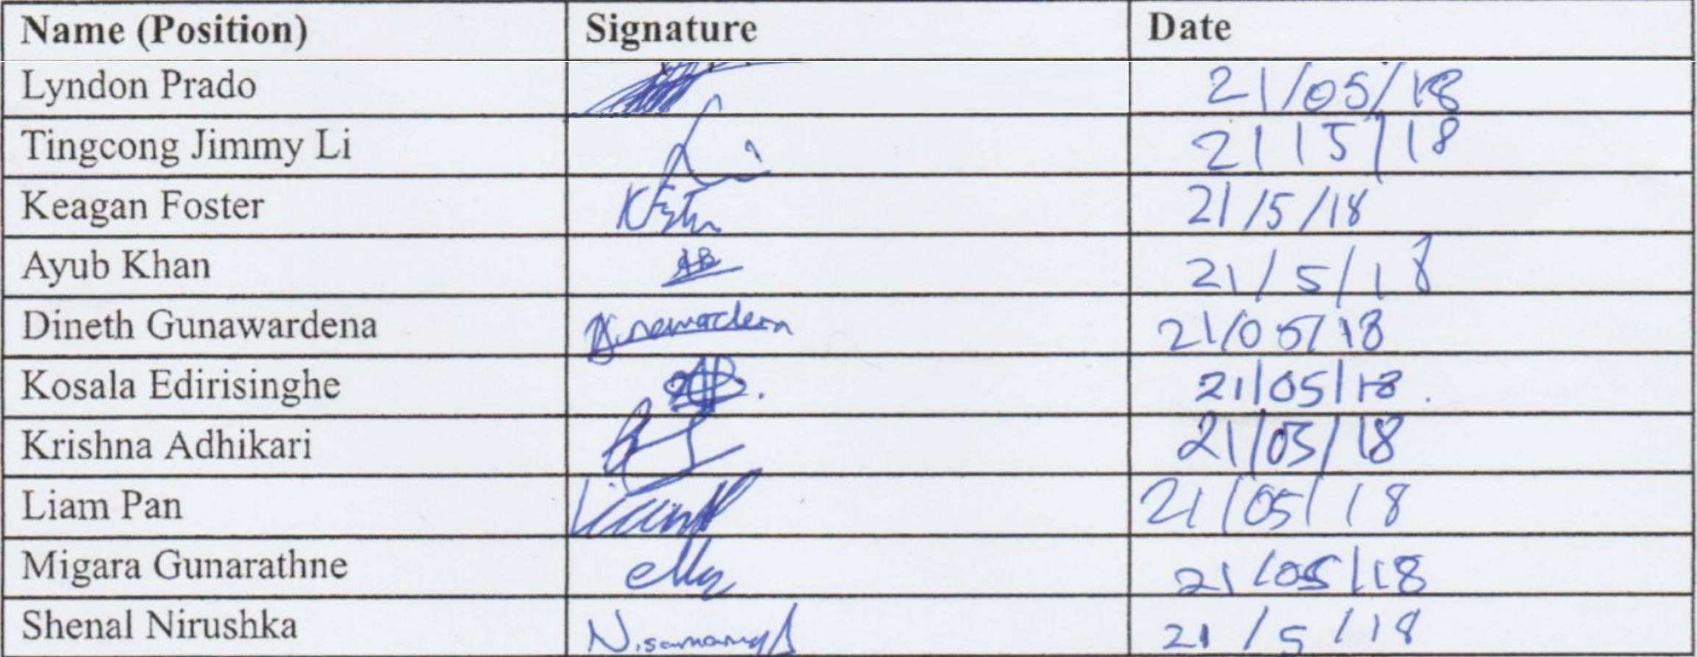

**Acronyms/Abbreviations**

**SGBRG -** Smart glass based remote guidance

**Smart Glass -** Vuzix M100 Smart Glasses

# **Table of Contents**

**Table of Contents** 3

1. Problem 4

1.1 Client’s Pain Points 4

1.2 Problem Analysis 4

1.3 Goals for solution 5

1.4 Data Analysis 5

1.5 Usability Guidelines 6

2. Solution 7

2.1 User Interface 7

2.2 Server 9

# Problem

## 1.1 Client’s Pain Points

The client proposed this project with the intention to solve the current issue of unclear teaching and guiding using remote communication methods currently available in industries. He informed us that current technology that aims to solve the issue are not practical due to several factors, including high costs, difficulty to setup and use, too big and restrictive. While he does not expect us to create a market ready system, a prototype must be developed to be presented at events which showcases the functionality of our solution.

## 1.2 Problem Analysis

To solve the client’s issues, he proposed project involves using smart glasses to allow for improved remote communication by video live streaming the operator’s perspective to the instructor and the instructor’s hand gestures to the operator. He also included implementing the functionality of the instructor being able to create a sketch using his hands and send it to the operator which requires hand gesture tracking. Lastly, for the purposes of the presentation the functionality of meat quality and dimensions processing and displaying had been included to demonstrate the use of this system for specific industries.

To solve the practicality issues that other systems when attempting to solve this problem, the smart glasses that have been provided to us are readily available off the shelf at a reasonable cost. Utilising smart glasses also means that the system should be very portable and does not restrict the operators field of view to greatly. To solve the difficulty of setting up and using the system, we must ensure that system is user-friendly and avoids a complicated setup and complex actions to operate our system. When designing our system, we need to keep our user in mind, always developing and testing the functionality from a user’s perspective and ensuring that the final solution is practical for the user.

One of the pieces of functionality we are implementing is meat quality grading, which requires the system to identify a piece of meat and display it’s quality and dimensions to the operator. Doing this involves utilising object recognition to identify the meat, which is a still image is then going to be processed by the smart glasses or server and have its RGB colour compared to the RGB colour range of meat quality that is available through APIs. The dimensions need to be measured either using a known point of reference to measure it or use process mathematical calculations on a still image to find the dimensions which then needs to be displayed to the operator.

Some of our limitations of this project is the hardware we have access to, as the client provided two Vuzix M100 smart glasses for this project. This limits our development as our development team cannot simultaneously implement code onto the devices to test it. Also, the smart glasses being released in 2014 meaning that it can only run a lower version on Android and therefore we cannot utilise some libraries for this project. Other limitations relate to the project lifespan of roughly 24 weeks spread out over this year, as well as the limited experience and capabilities of the development team. Both the time duration and knowledge of the team limit the scope of this project as any complicated or lengthy pieces of functionality that needs to be developed will take a proportionally large amount of time from the projects life span.

## 1.3 Goals for solution

For this project to be considered a success, we need to aim to achieve these following goals by the end of the project:

* Solution allows the operator to understand the instructors hand gestures (under half a second of delay between hand gesture and display)
* System only requires one connection setup; every other use works straight after switching on device
* Let the instructor view and understand the operator’s perspective
* System requires not complicated menu options or actions to use certain feature
* Allow for the operator to see meat quality and dimensions
* Allow sketching and sending of sketch

## 1.4 Data Analysis

Before beginning research in possible solutions for this project, the client provided some code from his previous projects that could aid us in the instructor’s hand segmentation from the background. He also provided us with some background knowledge on how meat quality is graded, such as using the RGB colour of the meat and comparing it to a range of RGB meat qualities, and ways we can implement that in our system.

We then began through this semester conducting multiple meetings with the client to ensure that we correctly defined the scope of this project as well as the functional and non-functional requirements. In these meetings we proposed our suggested solution to the client which he then gave feedback on and clarified if it meets his original idea for the project.

For our solution every member of our team was assigned research topics to discover useful information about how we can best implement this system. We researched the Vuzix M100 smart glasses and we discovered that they can only run Android 4.04, which was released in late 2011, compared to the latest version which is 8.1. After discovering this and checking through our researched libraries, we discovered that many of them do no support this older version of Android meaning that we will have to find new methods of creating certain functionality. We also researched other topics such as object recognition, machine learning, computer vision and other but did not find any drastic information that would significantly alter the way we design and develop our system.

## 1.5 Usability Guidelines

As we are designing this product for industry workers with no prior experience with smart glasses, we need the product to be user friendly so that users can operate the system with no training and guidance being required. To resolve this usability requirement, we are designing our system to be a user friendly as possible. As there are no definite usability guidelines that have been defined for smart glasses due to them being an emerging technology, we have defined created and borrowed some guidelines for our product to follow to ensure that we are meeting the usability requirements for our project. The guideline we created are:

* Utilise familiar gestures in product, such as pinching to zoom in, that is like other devices such as smartphones or tablets. This reduces the amount of learning time required for the product, as the gestures are already known to the user.
* Design information presented to the user around the small screen size. All information presented to the user must be essential data that assists the user in completing desired actions.
* Avoid creating visual content merely for appearance's sake. Make all  
  visual elements serve a functional, beneficial purpose related to information presentation.
* Use icons for supplementary information, not as a primary information delivery vector. Furthermore, use existing, well-known icons that users are bound to be familiar with.
* Voice communication using the system should occur the least amount of delay when compared to other type of data sent.
* If using colour, then do not use muted tones. Do not use colour merely for appearance, but have it act as information separator/categorizer.
* Do not overly limit the displayed content as people are able to handle 5- 6 discrete elements on display without issues. Reducing element amount to 2-3 brings no significant benefit.

We aim to meet these guidelines by designing our system around requiring as little user interaction as possible to operate the system. Once the connection has been established through a preset connection record, the system works immediately after powering on. To utilise functions such as sketching and meat quality processing, we plan to implement either the buttons on smart glasses or simple hand gestures. Voice will be integrated into the system and will be automatically switched on by default when utilizing the system.

# Solution

## 2.1 User Interface

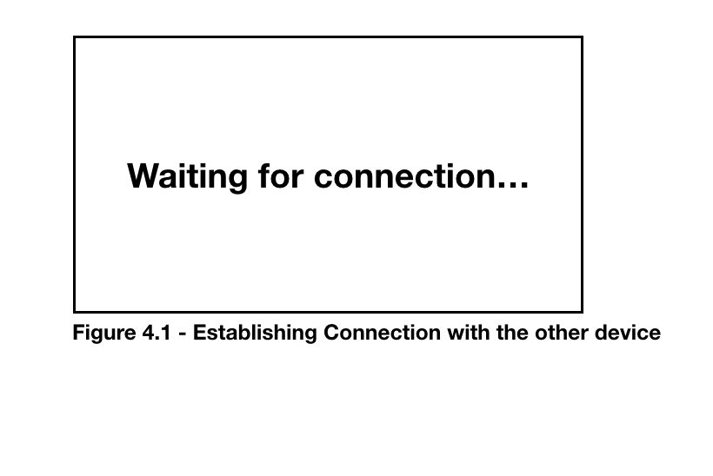

In the solution the connection between the two glasses will already be configured as either instructor or operator. Once the instructor switches on the glasses it will attempt to connect with the operator’s glasses and vice versa.

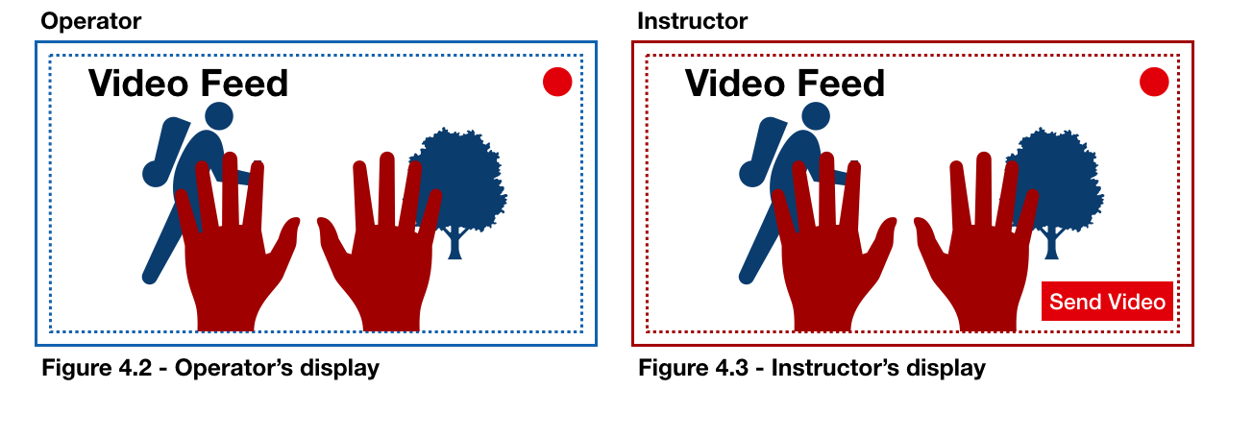Once the connection has been established the operator’s glasses will start broadcasting the video feed captured from its camera to both devices. The instructor’s glasses will capture the instructor’s hands and will overlay it on top of the video feed broadcasted by the operator. Both devices will see the same video feed (figure 4.2 and 4.3) with the what the operator sees (in blue) and the instructors hands (in red)

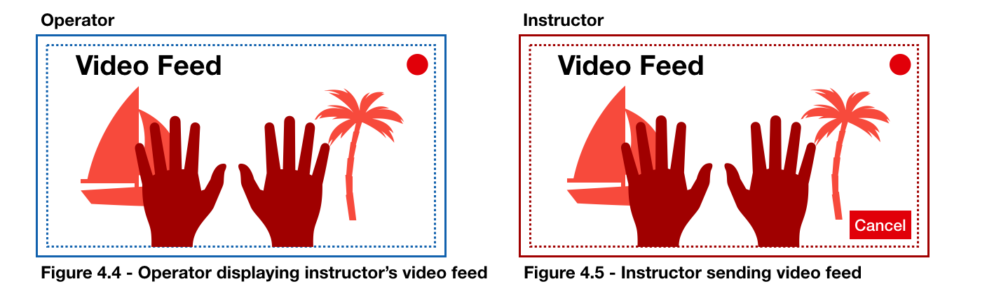

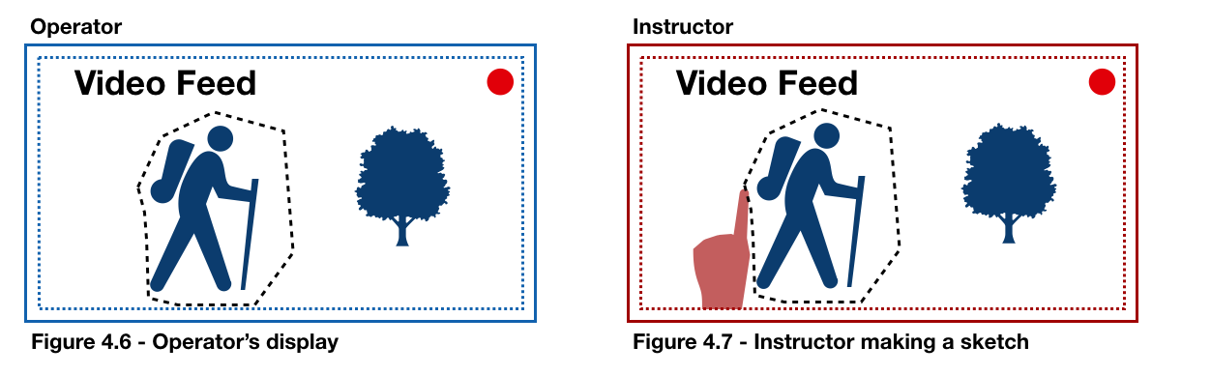When the operator selects the send video the device will start broadcasting the instructors video feed to the operator.Both devices will receive the same feed.

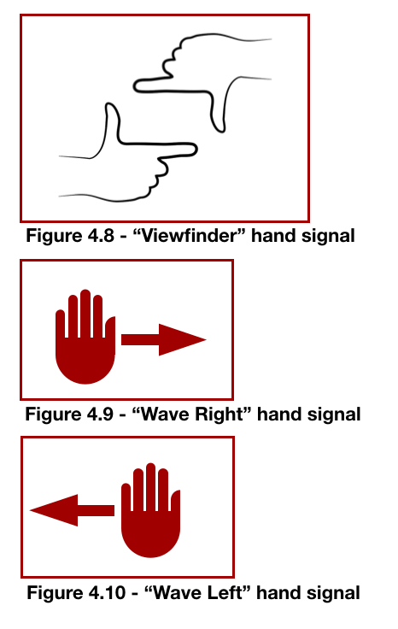

The instructor can capture a screenshot by using the hand gesture seen on figure 4.8. The instructor can also make sketches on the image with his finger as shown in figure 4.7. The instructor can wave right (see figure 4.9) to send the image to the operator. The instructor can discard the image by waving left (see figure 4.10).

The image sent by the instructor will be displayed on the operator’s screen. The operator can wave right or left to dismiss the image after viewing it. Once the operator had dismissed the image the display will return to the video feed . Once instructor has sent of dismissed the image the instructors display will return to the video feed

We aim to meet the user needs for this system by developing a minimalistic user interface that requires little user interaction to begin utilising the system. Once the connection settings have been created, the system connects with the other pair of smart glasses for the user. From there, the hand gesture segmentation and video live streaming are automatically functioning, as well as the voice communication. To call upon functions such as sketching or meat quality processing, we are going to have either simple, recognizable hand gestures or buttons which allow the user the easy access these with uses our system. We aim to make the user interface as simple to use as possible so that we can focus on ensuring that this product has a greater chance of being adopted by industries.

## 2.2 Server

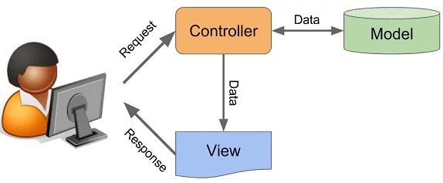

The server architecture pattern that we are have designed our system around is based around a Model View Controller type. The server functions as both the controller and the model, as it processes the requests from the user and alters the data in the model accordingly.

The server also produces the presents the what’s the user sees, as it processes the video stream from one user and sends it to the other user. The server listens for HLS and inputs from devices, processing the input and video using OpenCV and outputs the video result to the other user on the server. The user can interact with the system by making hand gestures or pressing the buttons on the smart glasses, which acts as a request to the controller to call upon certain functions.